**Part 1**

1.1 Use 'gvm-start' command to start GVM. After GVM is started, run the 'sudo ss -antp' command in a terminal. Based on the output of this command, explain which port the GSA daemon is listening on, and attach a screenshot as proof.

The daemon “gsad” is listening on port 9392

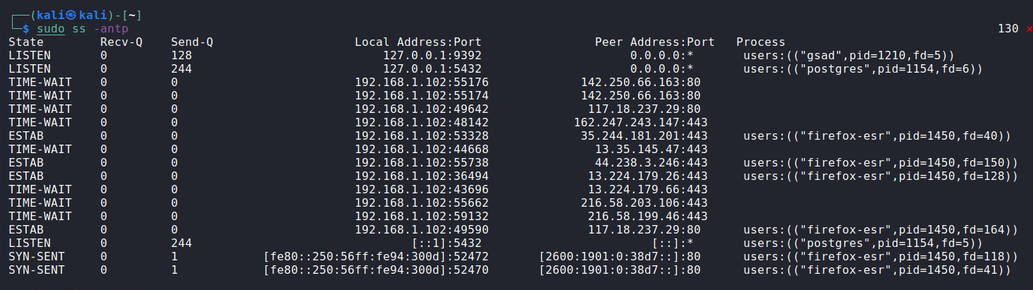

1.2 Change the password of the GSA user 'admin' to be 'admin123'. Write your command line into your lab report, and attach a screenshot to prove that it is executed without errors.

**sudo runuser -u _gvm -- gvmd --user=admin --new-password=admin123**

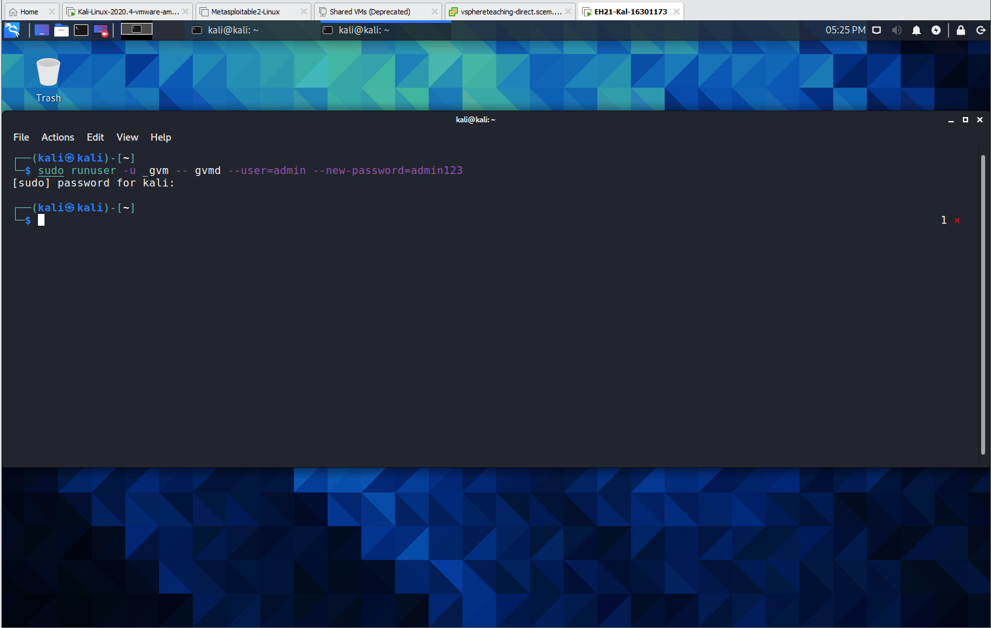

1.3 What’s the URL for Firefox to access the GVM web interface?

**https://localhost:9392/ or https://127.0.0.1:9392**

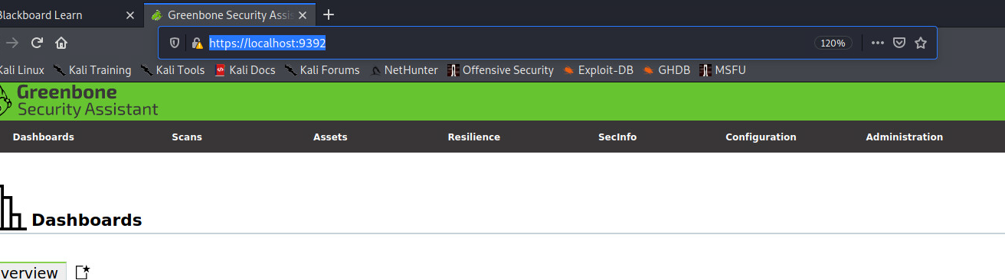

**Part 2**

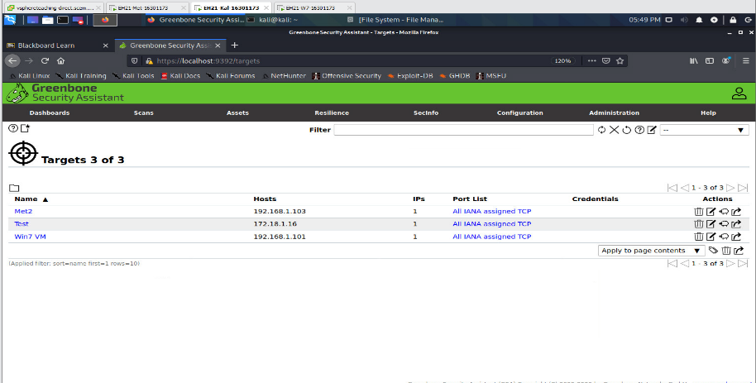2.1 Create targets for Win7 VM and Metasploitable2 VM respectively. You should choose options according to our lecture slides. Include a screenshot for each target creation into your lab report.

2.2 Explore the GSA web interface to find out the following:

a) How many TCP ports will be scanned if the port list ‘All IANA assigned TCP’ is used?

**5836 TCP total ports of these.**

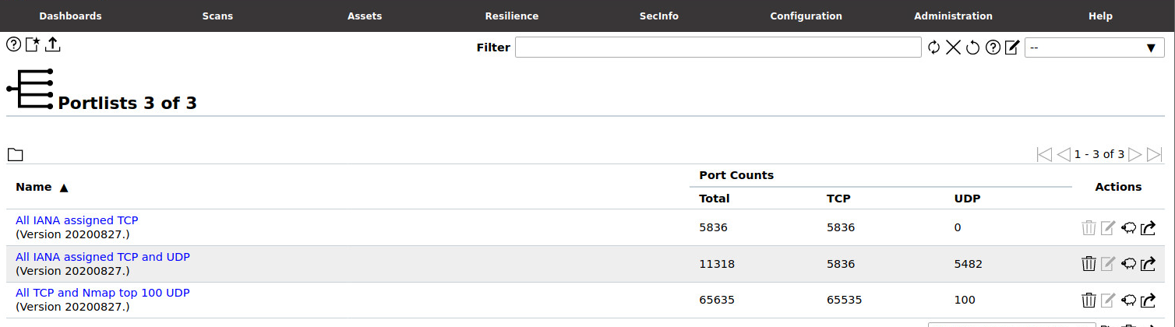

b) Will the TCP port '4' be scanned if this port list is used?

**No.**

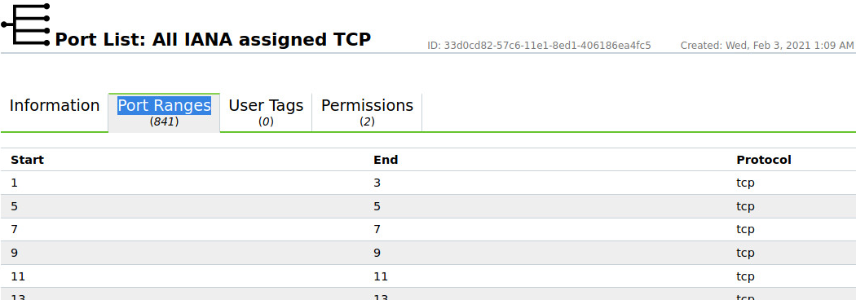

**Part 3**

3.1 Create a task to scan Win7 VM. Name this task 'Win7', and choose 'Full and Fast' for Scan Config. Include a screenshot of the task configuration into your lab report.  
  
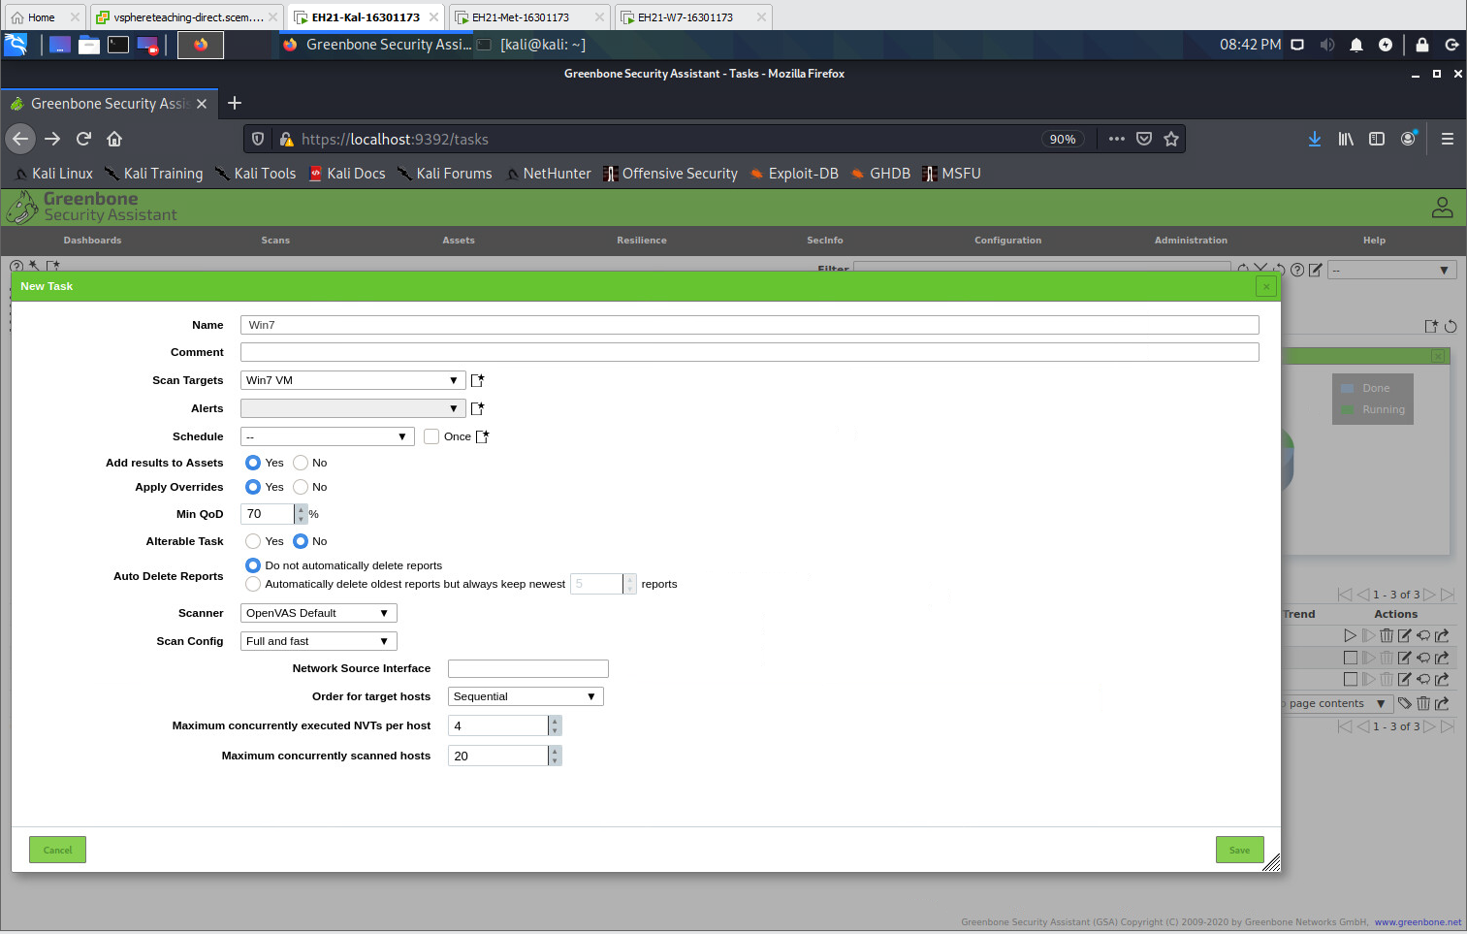

3.2 After the scan is done, download the GVM report in PDF. The report should be saved to the folder '/home/kali/Downloads'. Then, execute 'cd /home/kali/Downloads' and 'ls -l'. Based on the output of 'ls -l', what's the size of your GVM report for Win7 VM?

**130238 bytes**

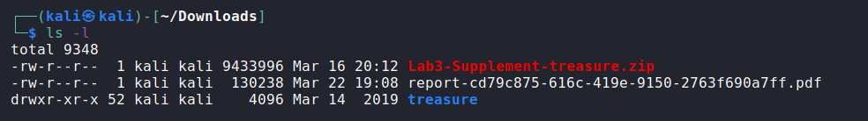

3.3 Rename this GVM report to a more meaningful name using the 'mv' command. Write your command line into the lab report.

**mv report-cd79c875-616c-419e-9150-2763f690a7ff.pdf win7-report.pdf**

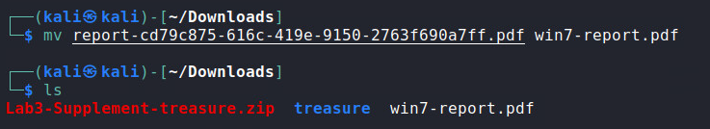

3.4 Use Firefox to visit uni email to email this GVM report to you, or you can use other means to transfer this report out of the virtual lab environment. Compare your GVM report for Win7 with the sample one provided to you on vUWS. Focus on the ‘Results Overview’ section of both reports. According to this section,

a) How many results of severity ‘High’ are reported in your report totally?

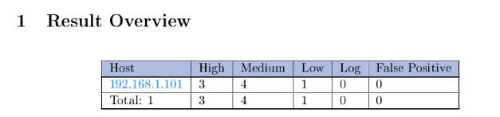**3**

b) How many results of severity ‘High’ are reported in the sample report totally?

**There are 3 in my one (above), and 2 in the sample lab report online.  
  
Sample:**

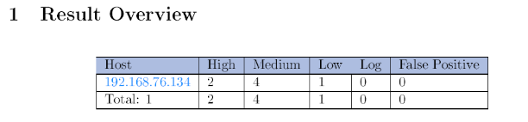

**Part 4**

4.1 Create a task to scan Metasploitable2 VM. Name this task 'Meta2-Discovery', and choose 'Discovery' as Scan Config. Include a screenshot of the task configuration into your lab report.   
  
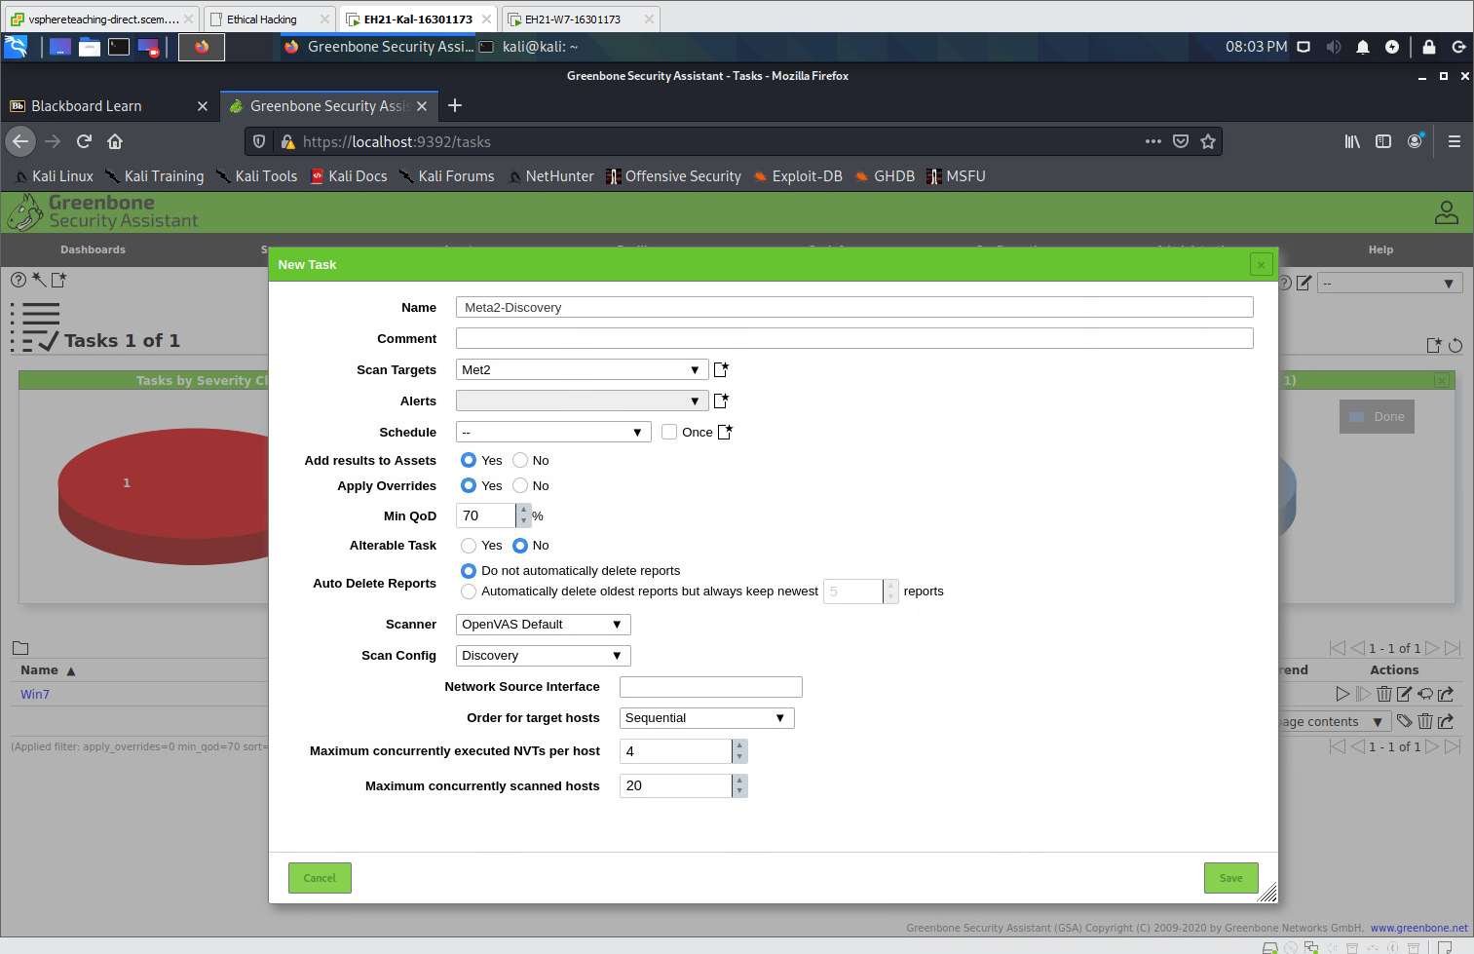

4.2 Explore the GSA web interface to find out how many NVTs will be executed under the 'Discovery' Scan Config?

**3003**

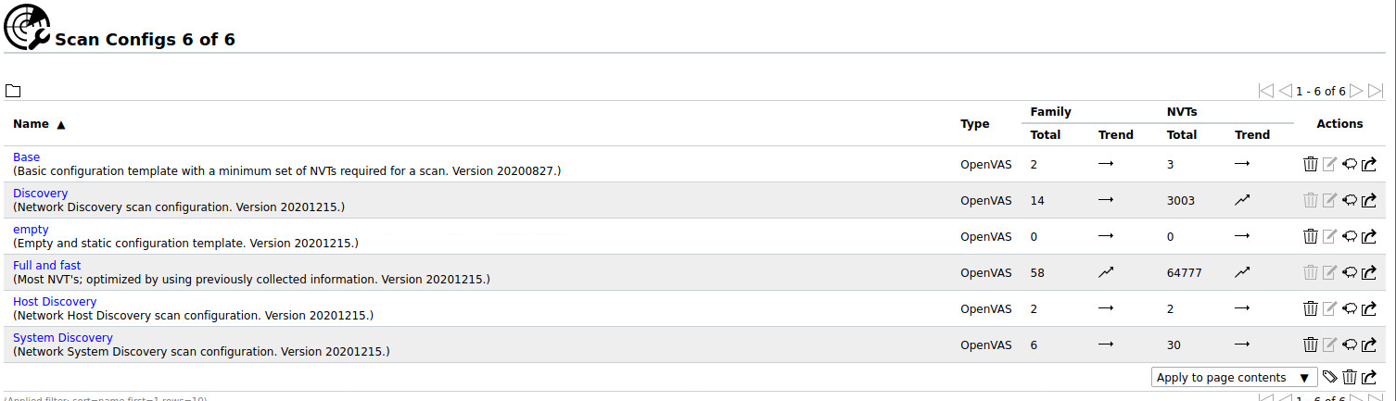

4.3 After the scan is done, download the GVM report in PDF. Then, run 'cd /home/kali/Downloads' and 'ls -l'. Based on the output of 'ls -l', what's the time of your GVM report for Metasploitable2 being saved?

**March 23 20:26**

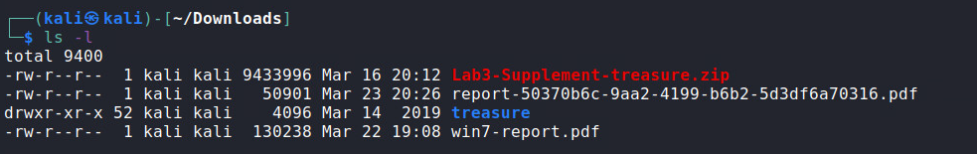

4.4 Rename this GVM report to a more meaningful name using the 'mv' command. Write your command line into the lab report.

**mv report-50370b6c-9aa2-4199-b6b2-5d3df6a70316.pdf met2-report.pdf**   
  
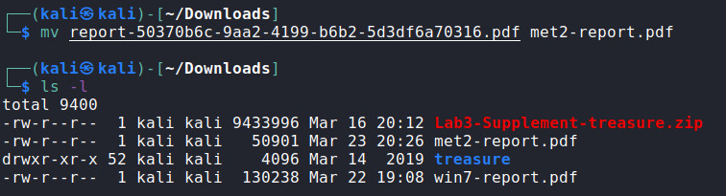

4.5 Use Firefox to visit uni email webpage to email this GVM report to you, or you can use other means to transfer this report out of the virtual lab environment. Look at the ‘Results Overview’ section of this report. According to this section, how many results of severity ‘High’ are reported totally?

**“0”**

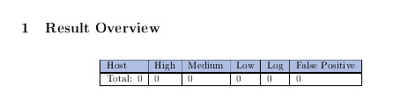

4.6 Create a second task to scan Metasploitable2 VM. Name this task 'Meta2-Full', and choose 'Full and Fast' as Scan Config. Include a screenshot of the task configuration into your lab report.

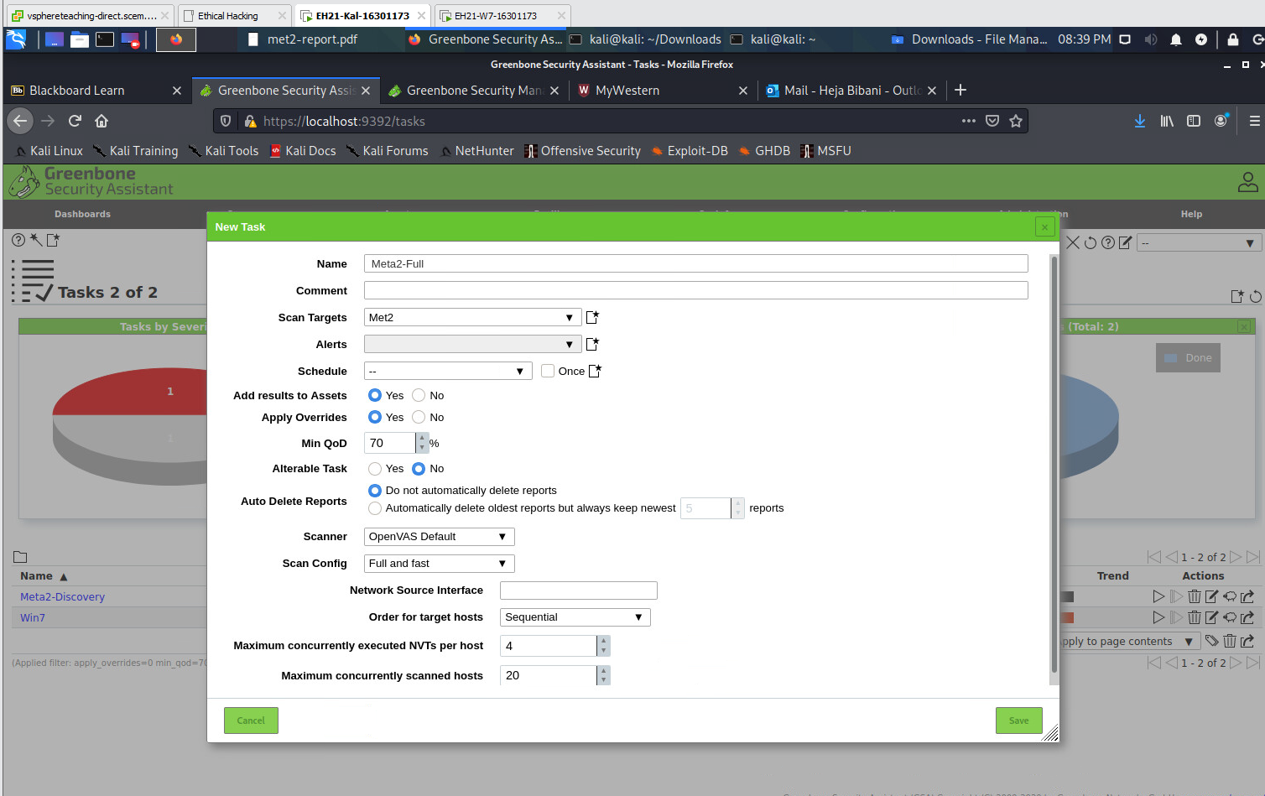

4.7 Explore the GSA web interface to find out how many NVTs will be executed under the 'Full and Fast' Scan Config?

**64777**

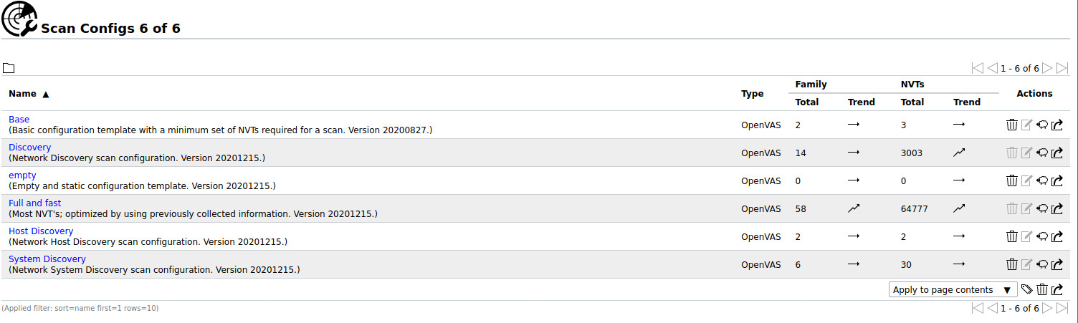

4.8 After the scan is done, download the GVM report in PDF. Rename this GVM report to a more meaningful name using the 'mv' command. Write your command line into the lab report.

**mv report-47167e04-f45d-40d0-a6c4-4ee97a6b2d58.pdf met2-Full-report.pdf**

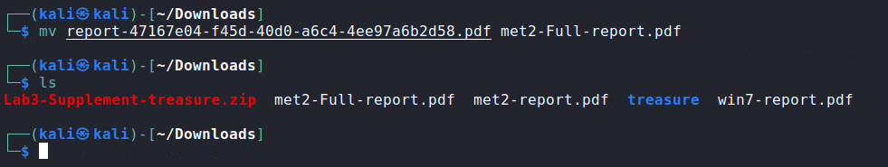

4.9 Use Firefox to visit uni email webpage to email this GVM report to you, or you can use other means to transfer this report out of the virtual lab environment. Look at the ‘Results Overview’ section of this report. According to this section, how many results of severity ‘High’ are reported totally?

**23**

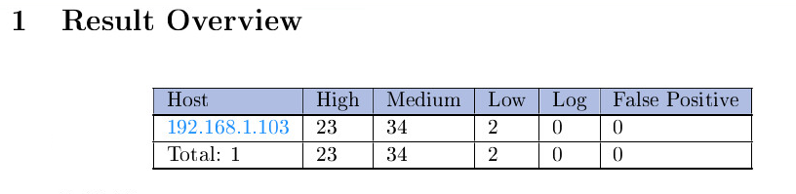

**Part 5**

5.1 Look at your GVM report for Win7.

a) How many results have severity 'Medium' according to the ‘Results Overview' section?

**4**

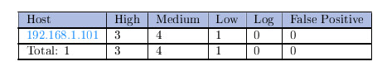

b) In the 'Results per host' section, under the TCP port 445, there should be one result with severity 'High'. What is the name of the NVT that detect this result?   
  
**NVT: Microsoft Windows SMB Server Multiple Vulnerabilities-Remote (4013389)**

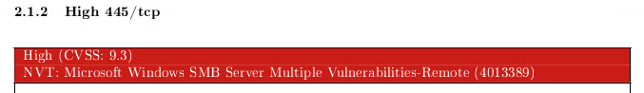

c) Study the details of the result mentioned in b) above. Answer the following questions in your lab report.

i) What is the solution recommended for this vuln?

**VendorFix: By performing a patch or an update that has been released by the vendor.**

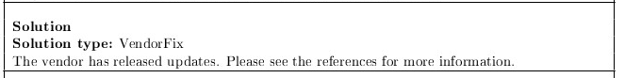

ii) What are the affected OSes listed for this vuln?

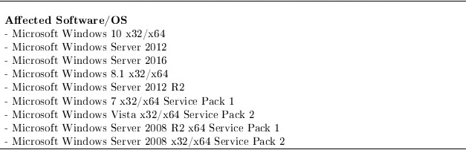

iii) What are the related CVE IDs and BIDs for this vuln?

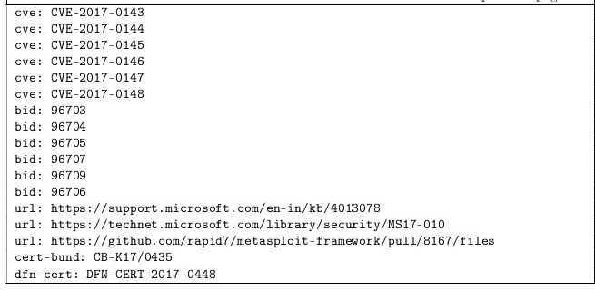

5.2 Look at your GVM report from task 'Meta2-Full' for Metasploitable2.

a) How many results have severity 'Medium' according to the ‘Results Overview’ section?

**34**

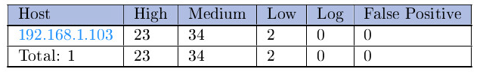

b) Study the details of the result "Java RMI Server Insecure Default Configuration Remote Code Execution Vulnerability". What are the summary and the solution listed for this vuln?

**Summary: Multiple Java products that implement the RMI Server contain a vulnerability that could allow an unauthenticated, remote attacker to execute arbitrary code on a targeted system with elevated privileges.**

**Solution: The solution type is a “work around” which specifies to disable class-loading.**

